Description

* Ortho- (adjacent carbons)
* Meta- (separated by one carbon)
* Para- (on opposite sides of the ring)

Properties

* Can HB
  + Increase BP, MP, and solubility
* More acidic than other alcohols (lower pKa)
  + Because the aromatic ring can delocalize the charge of the conjugate base
* Electron-donating groups e.g. alkyl groups **decrease acidity**
  + Because they destabilize **negative** charges
  + (but remember they can help stabilize positive charges → that’s why more substituted carbocations have higher stability than less substituted carbocations)
* Electron-withdrawing groups e.g. electronegative atoms and aromatic rings **increase acidity**
  + Because they stabilize negative charges

Reactions of Alcohols

* Primary alcohol → aldehyde
  + PCC
* Primary alcohol → carboxylic acid
  + Sodium or potassium dichromate salts
* Secondary alcohol → ketone
  + PCC, sodium or potassium dichromate salts
* Alcohols can be converted to mesylates or tosylates to make them **better leaving groups** for nucleophilic substitution reactions
  + They serve as good protecting groups because many reagents (especially oxidizing agents) that would react with an alcohol cannot react with these compounds

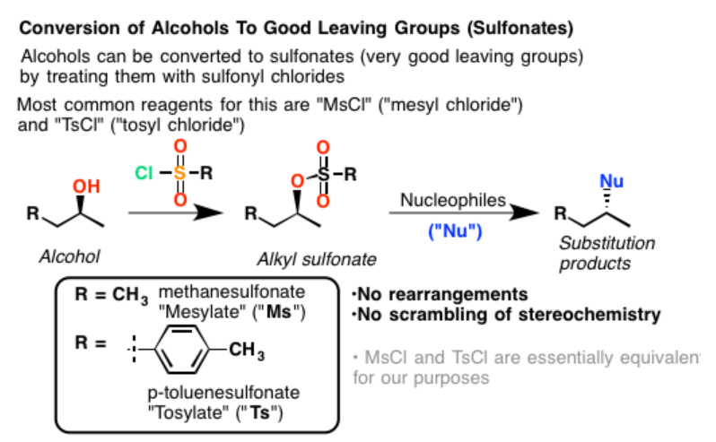

Protecting groups

* Aldehydes or ketones can be protected by converting them into acetals or ketals
  + Two equivalents of alcohol or a dialcohol are reacted with the carbonyl to form:
    - Acetal (a primary carbon with two -OR groups and a hydrogen atom)
    - Ketal (a secondary carbon with two -OR groups)
  + Other functional groups in the compound can be reacted (especially by reduction) without effects on the newly formed acetal or ketal
  + The acetal or ketal can then be converted back to a carbonyl by catalytic acid, which is called **deprotection** (shown below)

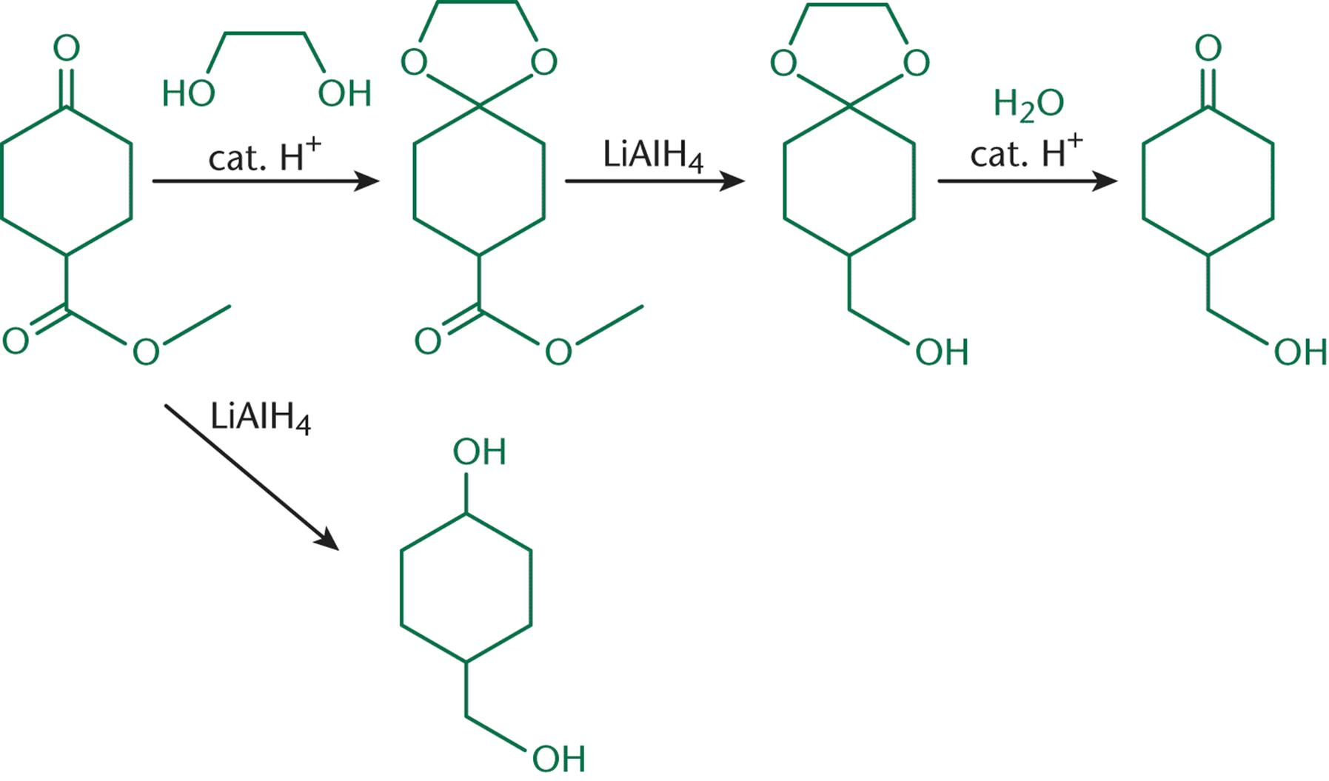

(Protection of a Ketone by Ketal Formation using a Dialcohol)

Reaction of Phenols

* Quinones are synthesized through oxidation of phenols
  + Quinones are resonance-stabilized electrophiles
  + Vitamin K1 (phylloquinone) and Vitamin K2 (menaquinone) are examples of biochemically relevant quinones
    - Both play a role in carboxylation of clotting factors in blood

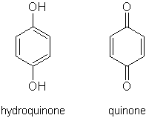

* Hydroxyquinones are produced by oxidation of quinones, adding a variable number of hydroxyl groups

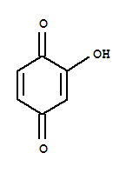

* Ubiquinone (coenzyme Q) is another biologically active quinone
  + Acts as an electron acceptor in Complexes I, II and III of the electron transport chain
    - Has conjugated rings, which stabilize the molecule when accepting electrons
    - The long alkyl chain in the molecule allows for lipid solubility, which allows the molecule to function in the phospholipid bilayer
  + Reduced to ubiquinol

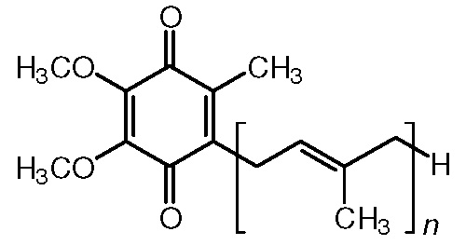

Hemiacetal, acetal, hemiketal, ketal

